**Recommender System Module 16**

**Business** **Problem**: Build a recommender system with the **Movies** Dataset using UBCF.

**Data:**

I don’t find any NA and missing values. Hence data are in Cleaned. It has 3 columns Userid , Movies and Rating.

**Graphical Representation of Rating:**

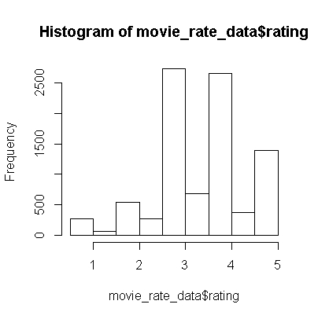

Compare with Real rating Matrix and generated data.

**Recommend based on Popularity for 1111th User Id:**

Based on popularity getting the data for 1111th user id for 8 movies are generated and mentioned below.



**Recommend based on UBCF (User Based Collaborative Filtering**)  **for 1166th User Id:**

Based on UBCF getting the data for 1166th user id for 5 movies are generated and mentioned below.



**Business** **Problem**: Build a recommender system with the **Anime** Dataset using UBCF.

**Data:**

I don’t find any NA and missing values. Hence data are in Cleaned. It has 7 columns Anime_id , Name, Genre, Type, Episodes, Rating and Members. Filter Anime_Id , Name and Ratings into another dataset further processing.

**Graphical Representation of Rating:**

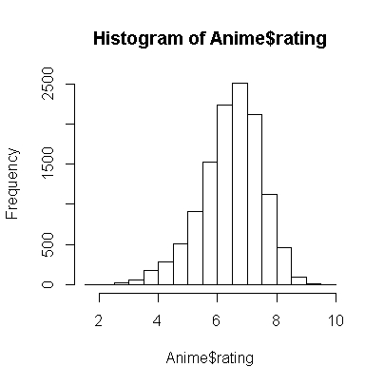

Compare with Real rating Matrix and generated data.

**Recommend based on Popularity for 1000th User Id:**

Based on popularity getting the data for 1000th user id for 5 names are generated and mentioned below.

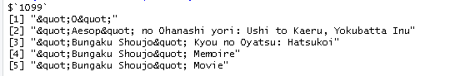

**Recommend based on UBCF (User Based Collaborative Filtering**)  **for 1000th User Id:**

Based on UBCF getting the data for 1000th user id for 5 names are generated and mentioned below.

Due insufficient memory, It is giving error with short of Processing space. Even though memory allocated dynamically.

**Top 15 names:**

